Function Plotting, Salting, and Smoothing

Overview
This Java program plots a mathematical function, adds randomness (referred to as "salting") to simulate noise, and then applies a smoothing algorithm to reduce the noise. The main goal is to simulate real-world data imperfections and explore a custom method to smooth out the data.

Function Plotting
This function calculates y = x^2 + x. The FunctionPlotter class generates 1001 data points from x = 0 to 1000 and exports the points to data.csv.

Salting the Data
The salting process simulates noise by adding a random number to the y-value of each data point. The values are read from data.csv, and new noisy values are written to salt_data.csv.
Originally, the program used a salt range of ±1,000,000. This added extreme variation that made the smoothing process ineffective. I then tested different salt ranges:
- First: ±1,000,000 → Too much noise
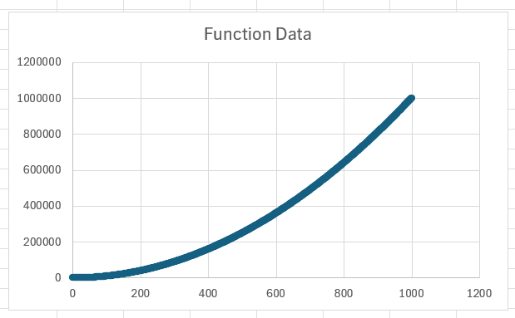
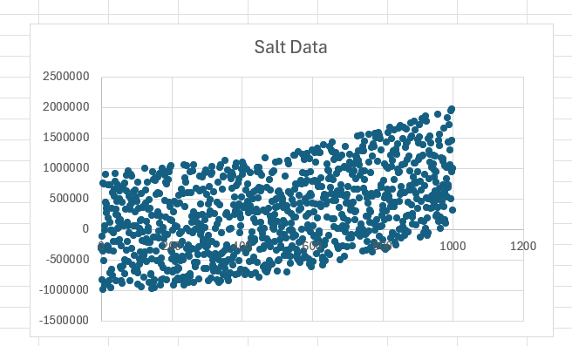
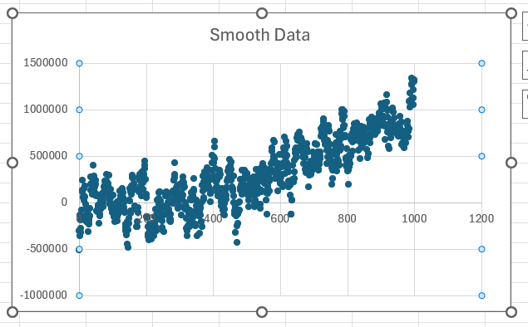

- Second: ±1,000 → Not enough noise
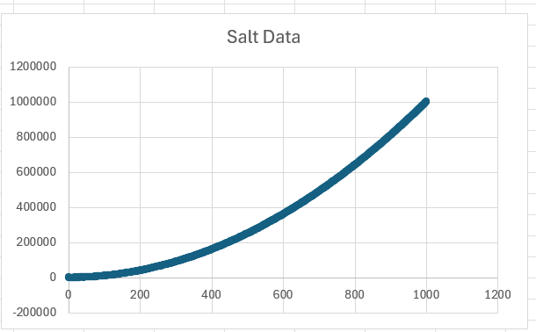
- Third: ±10,000 → Still not enough
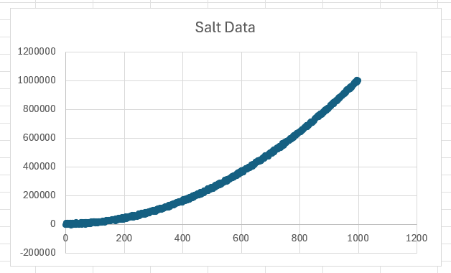
- Final: ±100,000 → Balanced amount of noise, smoothing became more effective
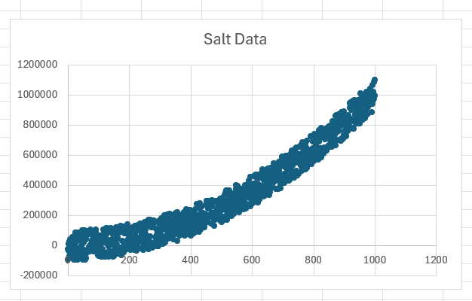
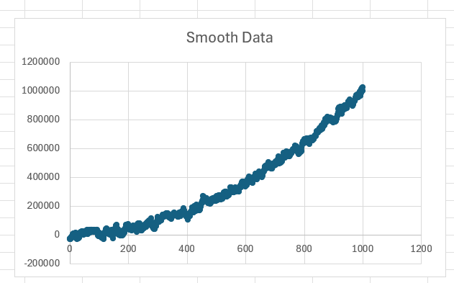
The final choice provided good noise that was still correctable through smoothing.

Smoothing the Data
The SmoothData class implements a custom smoothing technique The smoothing algorithm does the following:
- For each data point, it looks at the windowValue number of previous and next points (5 in this case).
- It calculates the sum of those surrounding y-values (excluding the current y-value).
- Then it takes the average of the surrounding values.
This approach smooths out extreme outliers introduced by the salting process, especially when using a moderate salt range like ±100,000.

Observations
- The smoothing method worked effectively once the salt range was adjusted to ±100,000, but I then adjusted my windowValue from 5 to 100 and the smoothing was even better.
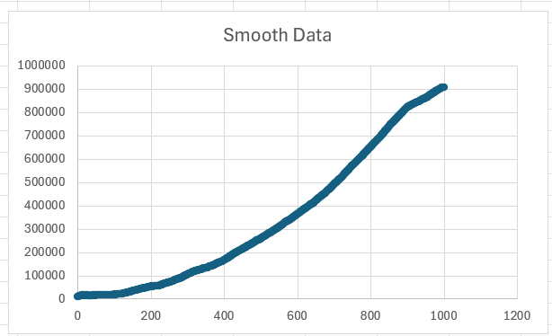
- Tried it with a windowValue of 500 but that did not turn out as well because most of the time in my data there were not 500 neighboring points.
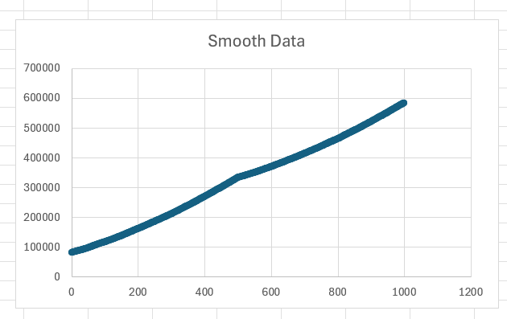
- The best result I got was with using a widowValue of 50. It was a balance between having it really smooth while also having enough neighboring points to check.
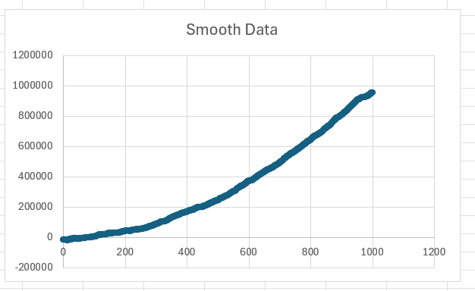

Conclusion
This program offers a hands-on demonstration of how data can be generated, corrupted, and recovered through smoothing. It was a valuable learning experience in handling noisy data and refining algorithms through testing and iteration.

